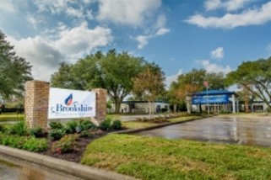

Brookshire Residence & Rehabilitation Center
Hiring RNs, LVNs and CNAs
710 Hwy 359 S Brookshire, TX 77423
Located 8 miles west of Katy Mills Mall, we have that “small town” feel but are easily accessible from I10. Our building has a secure memory-care unit,
a skilled nursing/therapy unit, and a long-term care unit.
We are always looking for skilled, caring professionals to join our team.

Please contact us at (281) 375-5272 or at info@brookshirecare.com

